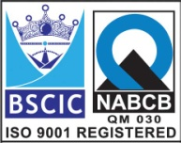



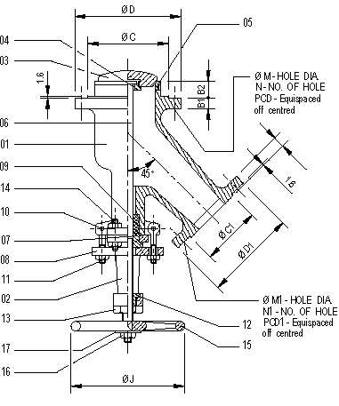 **“Y” Type Flush Bottom Tank Valve (Investment Casting)**

**Features:**

* Low Operating Torque
* Leak Tight Stem Sealing
* Pressure Rating – 150#
* End Connection – Flanged End, RF
* Flange Drilling – As per ANSI B16.5, 150#
* Operation – Manual Hand Wheel Operated

**Testing Standard:**

|  |  |  |
| --- | --- | --- |
| Test Pressure in PSIG | | |
| Test | Hydrostatic | Air |
| Pr. Rating | 150# |
| Body | 450 |  |
| Seat | 325 | 80 |

**Part List:**

|  |  |  |
| --- | --- | --- |
| **No.** | **Part Name** | **Materials** |
| 01 | Body | ASTM A315 Gr. CF8 / CF8M |
| 02 | Bonnet | ASTM A315 Gr. CF8 / CF8M |
| 03 | Plug | AISI 304 / 316 |
| 04 | Plug Nut | AISI 304 / 316 |
| 05 | Seat Ring | AISI 304 / 316 or Soft Seated |
| 06 | Screw | AISI 304 / 316 |
| 07 | Gland Bush | PTFE |
| 08 | Gland | SS |
| 09 | Gland Seal | PTFE |
| 10 | Bolt | SS |
| 11 | Nut | SS |
| 12 | Loking Screw | SS |
| 13 | Screw Nut | Gun Metal |
| 14 | Bolt & Nut | SS |
| 15 | Hand Wheel | SS |
| 16 | Hand Wheel Nut | SS |
| 17 | Washer | SS |

**Standard Dimensions:**

|  |  |  |  |  |  |  |  |  |  |  |  |  |  |  |
| --- | --- | --- | --- | --- | --- | --- | --- | --- | --- | --- | --- | --- | --- | --- |
| **Size** | **B** | **B1** | **B2** | **C** | **D** | **C1** | **D1** | **M** | **N** | **PCD** | **M1** | **N1** | **PCD1** | **J** |
| **1”x1”** | **14** | **14** | **50** | **51** | **108** | **51** | **108** | **16** | **4** | **79** | **16** | **4** | **79** | **125** |
| **1”x1.5”** | **14** | **14** | **50** | **73** | **127** | **51** | **108** | **16** | **4** | **98** | **16** | **4** | **79** | **125** |
| **1.5”x1.5”** | **14** | **14** | **50** | **73** | **127** | **73** | **127** | **16** | **4** | **98** | **16** | **4** | **98** | **150** |
| **1.5”x2”** | **14** | **16** | **50** | **92** | **152** | **73** | **127** | **19** | **4** | **121** | **16** | **4** | **98** | **150** |
| **2”x2”** | **16** | **16** | **50** | **92** | **152** | **92** | **152** | **19** | **4** | **121** | **19** | **4** | **121** | **150** |
| **2”x2.5”** | **16** | **17** | **50** | **105** | **178** | **92** | **152** | **19** | **4** | **140** | **19** | **4** | **121** | **200** |
| **2”x3”** | **16** | **19** | **50** | **127** | **190** | **92** | **152** | **19** | **4** | **152** | **19** | **4** | **121** | **200** |
| **2.5”x2.5”** | **17** | **17** | **50** | **105** | **178** | **105** | **178** | **19** | **4** | **140** | **19** | **4** | **140** | **200** |
| **2.5”x3”** | **17** | **19** | **50** | **127** | **190** | **105** | **178** | **19** | **4** | **152** | **19** | **4** | **140** | **200** |
| **3”x3”** | **19** | **19** | **50** | **127** | **190** | **127** | **190** | **19** | **4** | **152** | **19** | **4** | **152** | **200** |
| **3”x4”** | **19** | **24** | **50** | **157** | **229** | **127** | **190** | **19** | **8** | **190** | **19** | **4** | **152** | **250** |
| **4”x4”** | **24** | **24** | **50** | **157** | **229** | **157** | **229** | **19** | **8** | **190** | **19** | **8** | **190** | **250** |
| **4”x6”** | **24** | **25** | **50** | **216** | **279** | **157** | **229** | **22** | **8** | **241** | **19** | **8** | **190** | **250** |

**Due to continuous development Program, the design & data given in this leaflet are subject to change without prior notice.**

**ANITA ENGINEERING WORKS**



58-59, Narayan Estate, Opp. Shree Ram Estate, Nr. CMC Ltd. Odhav, Ahmedabad-382415, Gujarat, India

Phone: +91 79 22974101, Fax: +91 79 22875014

Email: eascovalves@yahoo.com, eascovalves@gmail.com, Web: [www.eascovalve.com](http://www.eascovalve.com)

